**Creating an interactive report**

**Introduction**

In the exercise *Creating an interactive report,* you were asked to build an interactive report that allowed viewers to drillthrough the data hierarchy based on month and navigate report pages using buttons and bookmarks.

Your task in this exercise was to:

* Create a new report page and configure the drillthrough for the sales month
* Add a slicer to filter by product category
* Create a bookmark for mountain bikes sold in March

This reading provides you with a step-by-step guide for completing these steps. It also includes screenshots that you can compare against your work.

**Step 1: Create the Sales Detail page**

1. Download the *Creating an interactive report.pbix* file and open it in Power BI. The **Q1 Sales Summary** page will be displayed.

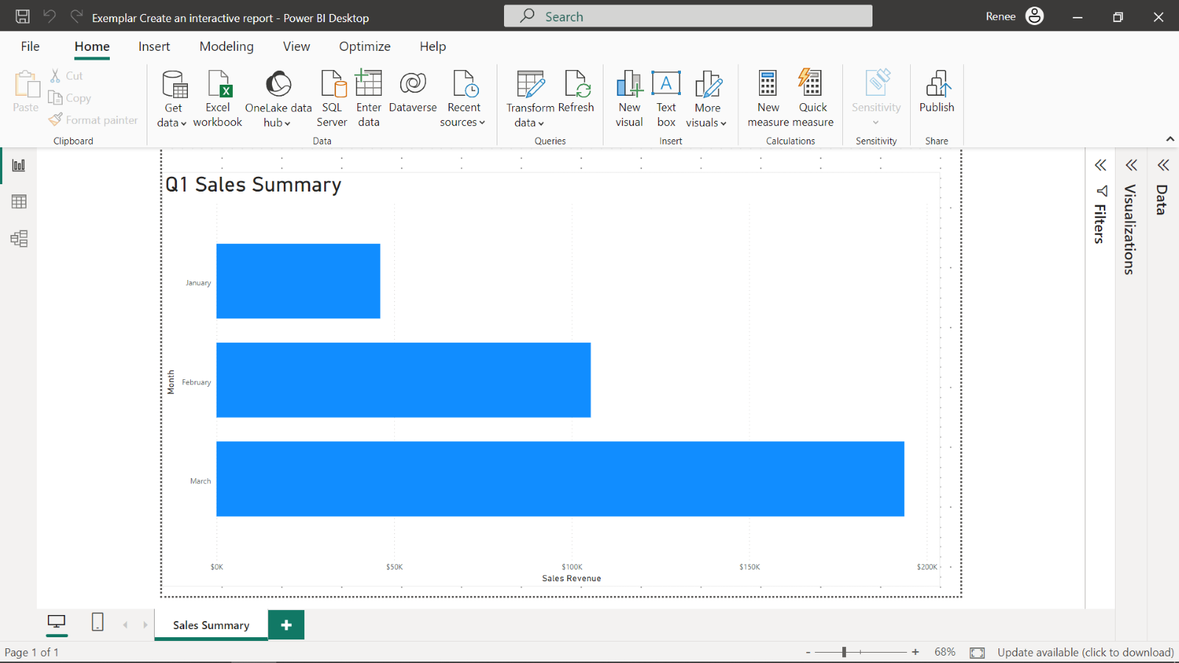

1. Select the **Plus** icon beside the **Sales Summary** tab to create a new report page. Name the report page **Sales Detail**.

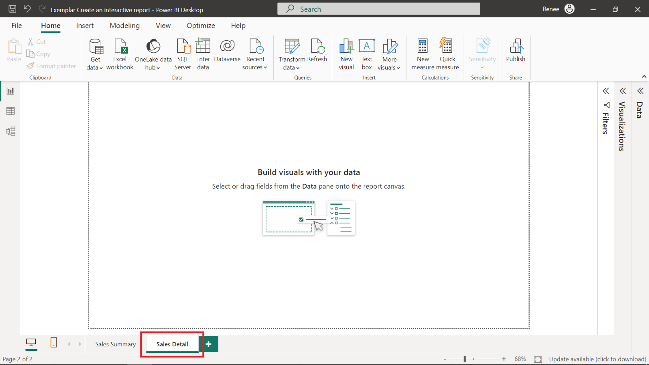

1. Add a table visualization containing a summary of sales revenue per customer location.

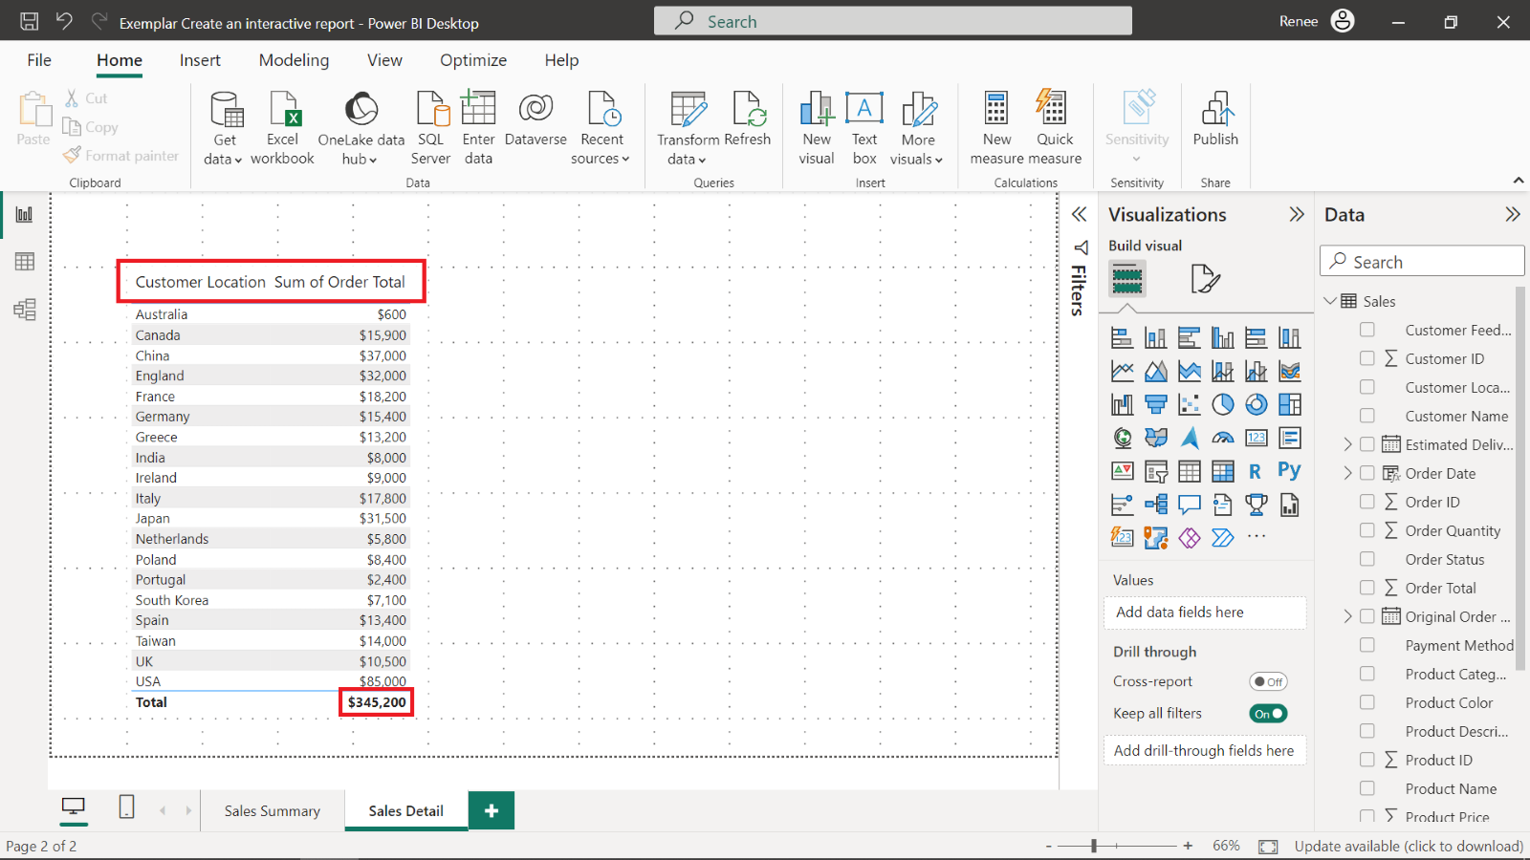

1. The **Total** sales revenue is displayed as $345,200 in the summary row at the bottom of the table.

**Step 2: Connect the order Month as the Drillthrough field**

1. Open the Data pane and expand the **Order Date** field in the **Data** pane.
2. Drag the **Month** field from the **Data Hierarchy** to the **Drillthrough** field of the table.

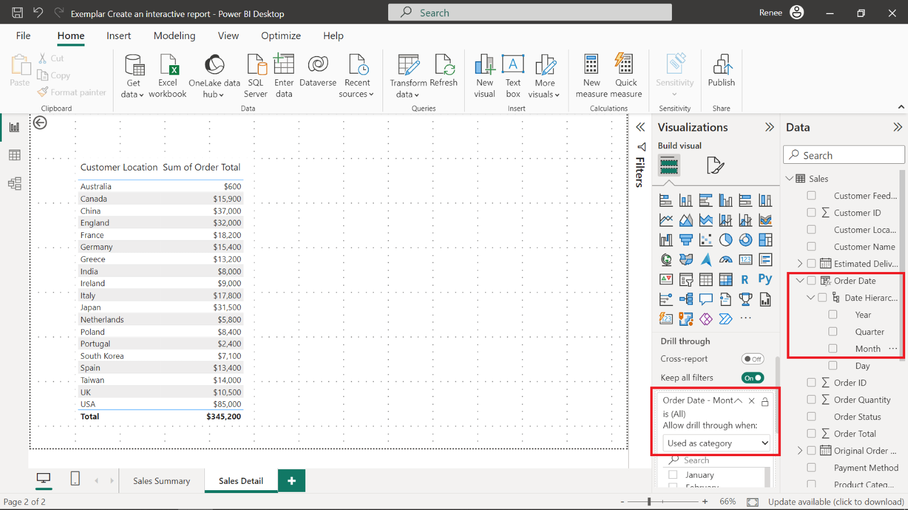

Power BI automatically creates a **back arrow** button in the top-left corner of the report page. Holding the **control** key and selecting the **back arrow** button will navigate to the **Sales Summary** page.

**Step 3: Add a slicer for Product Category**

1. Open the **Sales Summary** page.
2. Add a slicer visualization and select **Product Category** as the filter field.

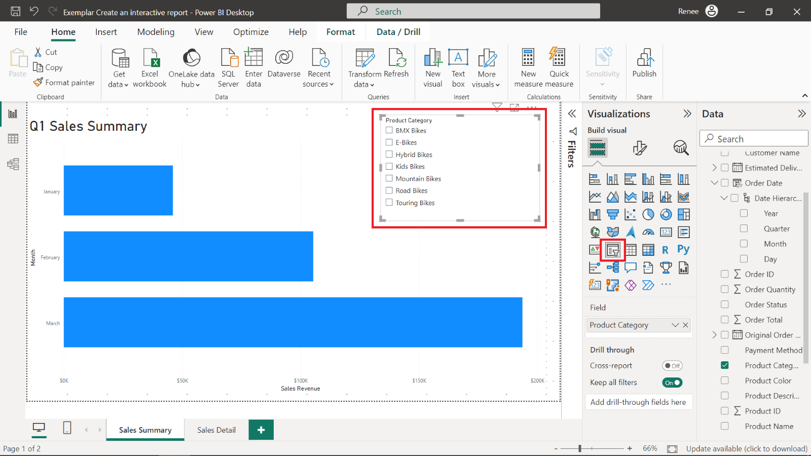

**Step 4: Add a bookmark for Mountain Bikes sold in March**

1. Select **Mountain Bikes** in the slicer to filter the data to only sales in the **Mountain Bike** product category.

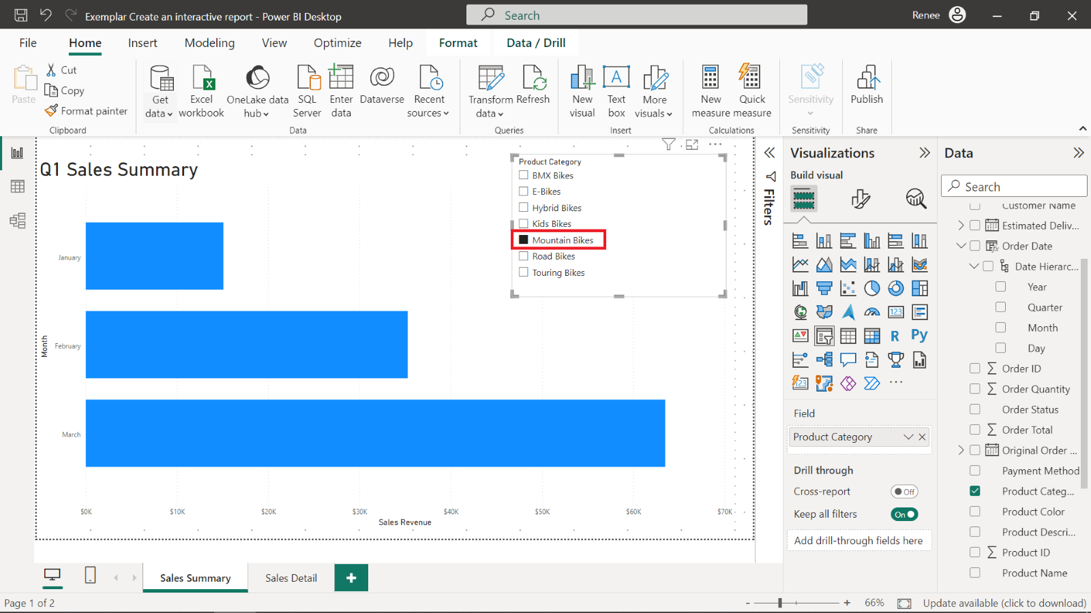

1. Right-click the **March** column, select **Drill through** and then **Sales Detail**.

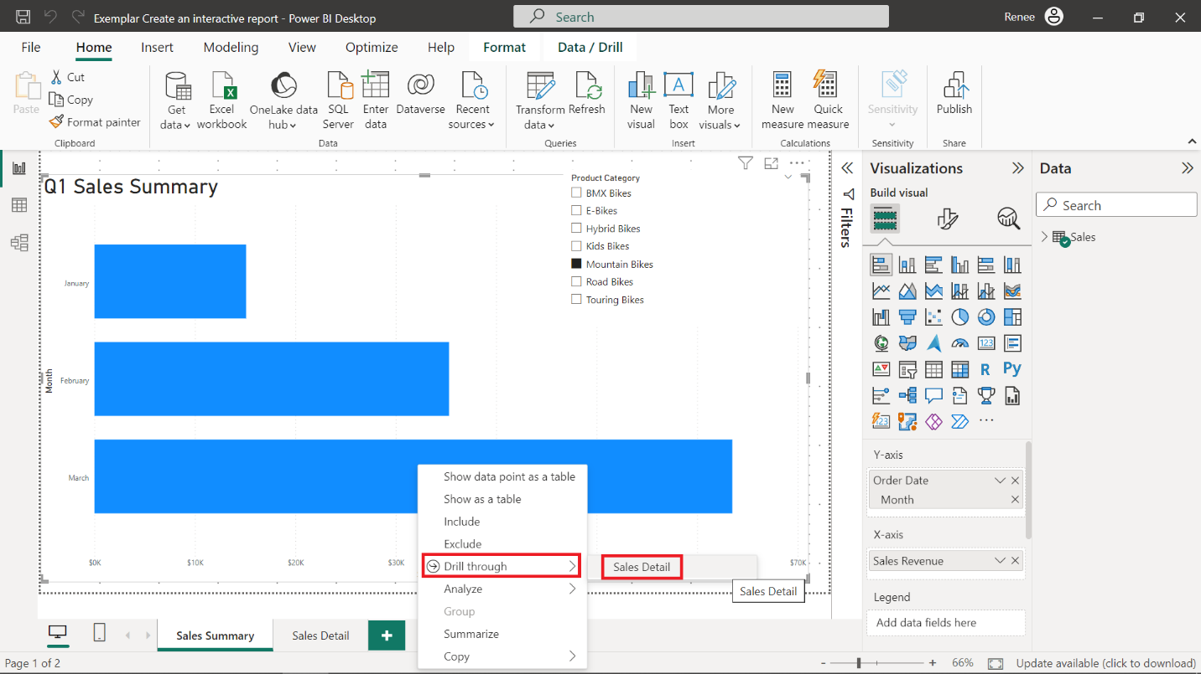

1. Navigate to the **View** tab in the Ribbon and select **Bookmarks**. In the **Bookmarks** pane, select **Add** to add a new bookmark and rename it **March Mountain Bikes Revenue.**

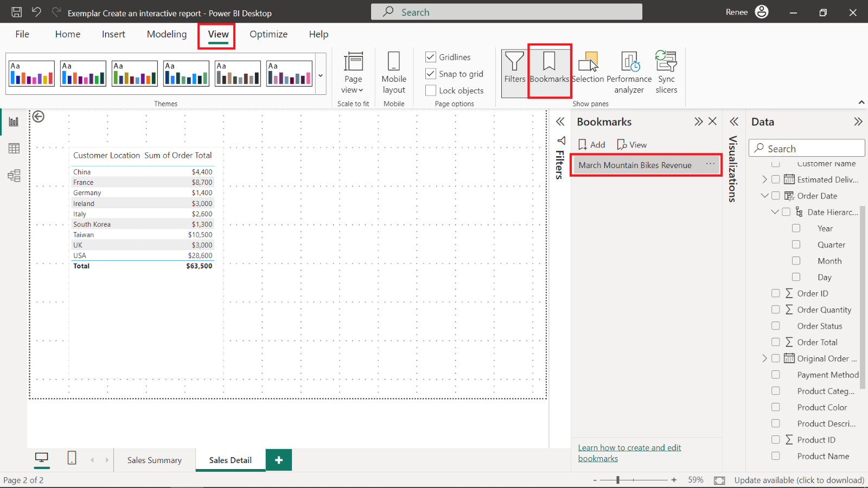

1. Select the bookmark to restore the filtered state. The **Total** sales revenue is $63,500 in the **Sales Detail** page.

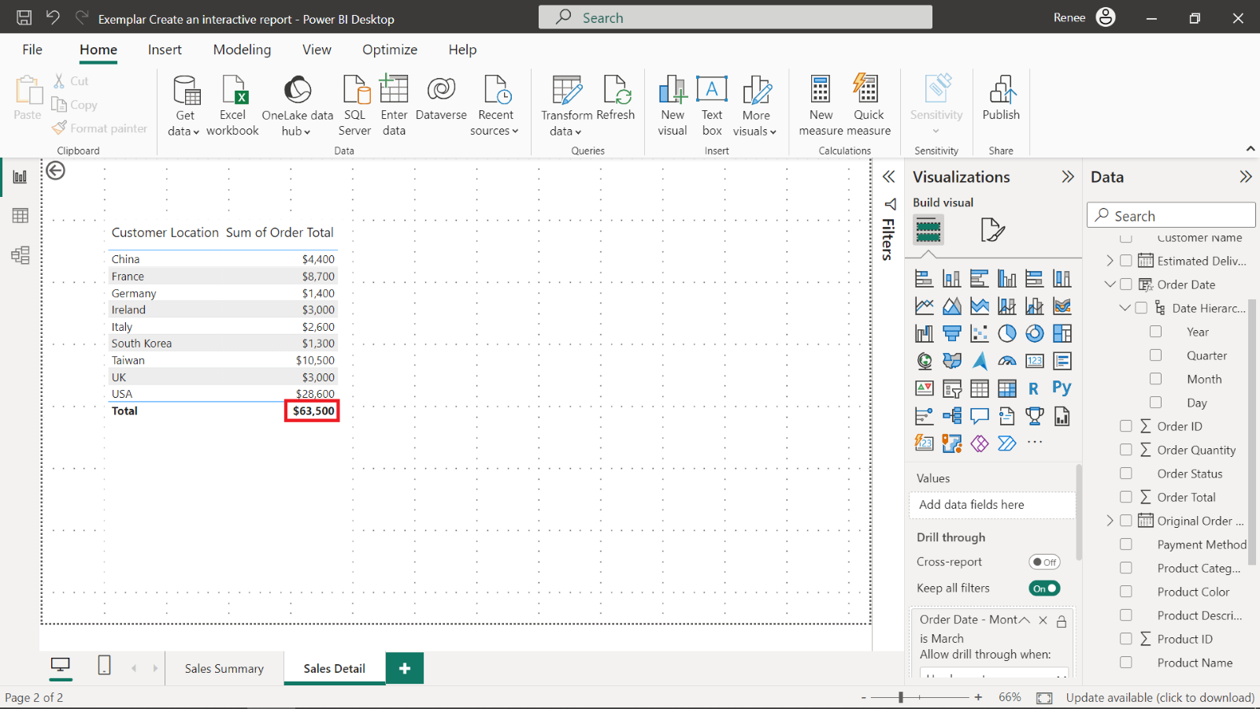

**Conclusion**

Congratulations! You have successfully completed this exercise. By adding the drillthrough, button, slicer, and bookmark features to the Power BI report, you've elevated it by making it more interactive and engaging. These tools give you the power to deliver valuable insights and create a smoother experience for your audience. As you keep working on your reports, these skills will be a valuable asset, helping you create more impactful, interactive, and user-friendly presentations.